Vernelle H. (Sprunger) Yoder
April 3, 1920 – August 2, 2015

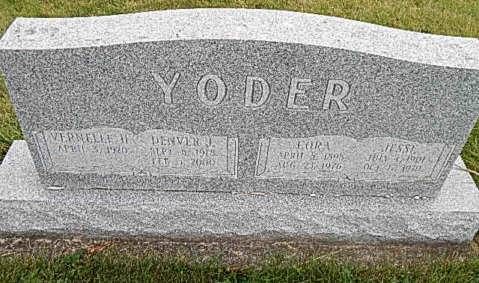
Photo by Alicia Kneuss

Vernelle H. Yoder, 95, Berne, passed away on August 2, 2015 while a patient at Lutheran Hospital. She was born to Alfred and Robertine Liechty Sprunger on April 3, 1920 in Adams County. She married Denver Yoder on November 23, 1939. She was a loving wife and a homemaker.
She had been a member of the Berne Evangelical Church for many years where she previously taught Children's Sunday School and enjoyed the Ladies Aid. Her special interests include; gardening, quilting, caring for her flowers and playing games.
Survivors are Evan (Janet) Yoder of Kokomo, Joye (Denver) Thompson of Berne, Steven (Karen) Yoder of Bluffton, Joan (Rodney) Liechty of Berne, Edward (Mary) Yoder of Bluffton, Gary (Connie) Yoder of Berne, 21 grandchildren, 44 great-grandchildren, and 1 great-great grandchild.
Preceding in death are her parents, husband, brothers; Irvin, Arthur, Vernon, sisters; Florence Moser, Gertrude Wulliman, Goldie Liechty, Ruth Sprunger and Anna Rich.
Funeral services are Saturday, August 8, 2015 at 10:30 am at the Berne Evangelical Church rural Berne with visitation 1 hour prior to services. Visitation also Friday, August 7. from 2 to 8 pm at the Yager-Kirchhofer Funeral Home, Berne. Officiating is Pastor Craig Thompson and Pastor Kent Fahl. Burial in the Evangelical Mennonite Church Cemetery. Preferred memorials are to Berne Evangelical Church Missions &/or Miracle Hill Ministries, Greenville, S.C. Sign guest book at yagerkirchhofer.com

Yager-Kirchhofer Funeral Home, Adams County, IN
September 13, 2015

