Goldie Yoder
September 16, 1915 – November 15, 1980

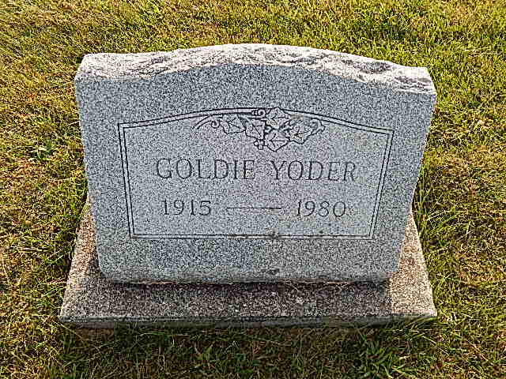
Photo by Alicia Kneuss

Indiana, Death Certificates, 1899-2011

Name: Goldie Yoder
Gender: Female
Race: White
Age: 65
Marital status: Never Married (Single)
Birth Date: 16 Sep 1915
Birth Place: Indiana
Death Date: 15 Nov 1980
Death Place: Fort Wayne, Allen, Indiana, USA
Father: David Yoder
Mother: Emma Luginbill
Informant: Arlene Conners
Burial: Nov. 18, 1980; Evangelical Mennonite Church Cemetery

