Elizabeth (Moser) Yoder
March 1847 – July 8, 1932

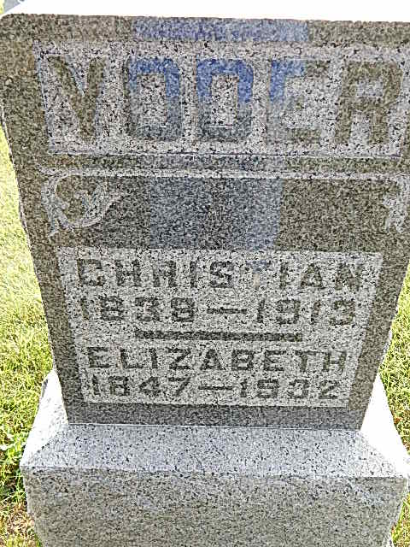
Photo by Alicia Kneuss

Indiana, Death Certificates, 1899-2011

Name: Elizabeth Yoder [Elizabeth Moser]
Gender: Female
Race: White
Age: 85y, 4m
Marital status: Widowed
Birth Date: Mar 1847
Birth Place: Indiana
Death Date: 8 Jul 1932
Death Place: Berne, Adams, Indiana, USA
Father: Joseph Moser
Mother: unknown
Informant: J K Yoder
Burial: 7/11/1932, Defenseless Mennonite

