Christian Yoder
April 5, 1838 – January 14, 1913

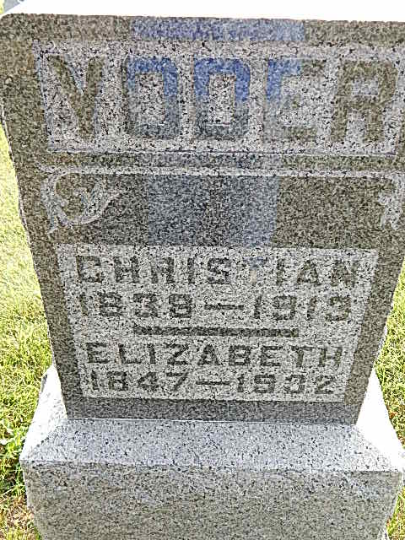
Photo by Alicia Kneuss

Indiana, Death Certificates, 1899-2011

Name: Christian Yoder
Gender: Male
Race: White
Age: 74y, 9m, 9d
Birth Date: 5 Apr 1838
Birth Place: France
Death Date: 14 Jan 1913
Death Place: Berne Ind, Adams, Indiana, USA
Father: John Yoder
Mother: not listed
Spouse: Elizabeth Yoder
Informant: Amos Yoder
Burial: 1/17/1913, Defenseless Mennonite

