Catherina (Reicher) Winteregg
1840 - 1926

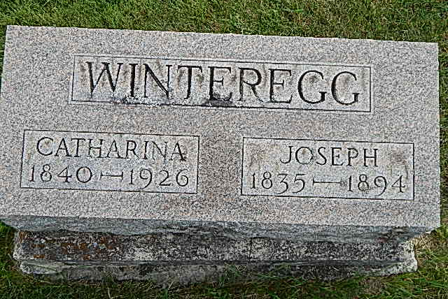
Photo by Alicia Kneuss

Indiana, Marriages, 1810-2001

Name: Catharine Reicher
Gender: Female
Event Type: Marriage Registration (Marriage)
Marriage Date: 20 Mar 1865
Marriage Place: Indiana, United States
Spouse: Joseph Winteregg
Officiator: John McConnel
Page: 438

