William S. Thompson
August 19, 1885 – October 27, 1966

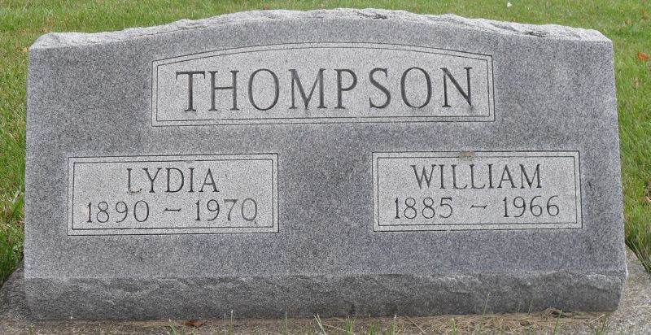
Photo by Stephen & Andrea Brangan

Indiana, Death Certificates, 1899-2011

Name: William S Thompson
Gender: Male
Race: White
Age: 81
Marital status: Married
Birth Date: 19 Aug 1885
Birth Place: Indiana
Death Date: 27 Oct 1966
Death Place: Fort Wayne, Allen, Indiana, USA
Father: John Thompson
Mother: Mary Nelson
Informant: Mrs. Florine Thompson, daughter-in-law
Burial: 10/31/1966, MRE Cemetery

