Lydia (Simon) Thompson
March 15, 1890 – January 7, 1970

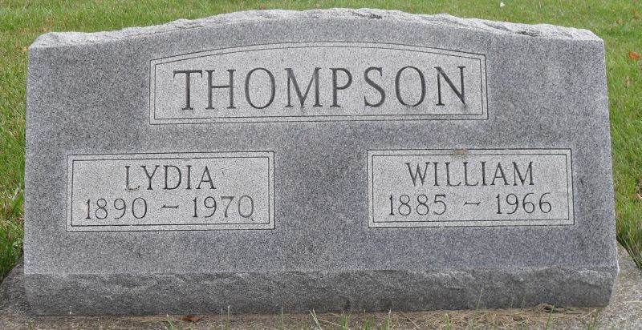
Photo by Stephen & Andrea Brangan

LYDIA THOMPSON DIES AT HOSPITAL
Mrs. Lydia Thompson, 79, of 355 West Franklin street, Berne, died at 8:15 a.m. Wednesday at the Adams County memorial hospital, where she had been admitted Monday. She had been ill for five weeks.
A lifelong resident of Adams County, she was born in French township, March 15, 1890, a daughter of Anthony and Mary Burry-Simon, and was married to William S. Thompson Aug. 29, 1908. Her husband preceded her in death in 1966.
Mrs. Thompson was a member of the Evangelical Mennonite church, west of Berne.
Surviving are one son, Earl W. Thompson of Berne; one brother, David Simon of Berne and one grandson. Four brothers and three sisters are deceased.
Services will be held at 2 p.m. Friday at the Yager funeral home in Berne, with Rev. Robert Zehr officiating. Burial will be in the Evangelical Mennonite church cemetery. Friends may call at the funeral home after 7 p.m. today.
Decatur Daily Democrat, Adams County, Indiana
Thursday, Jan. 8, 1970

