Rachel (Snyder) Stucky
November 4, 1881 – October 17, 1913

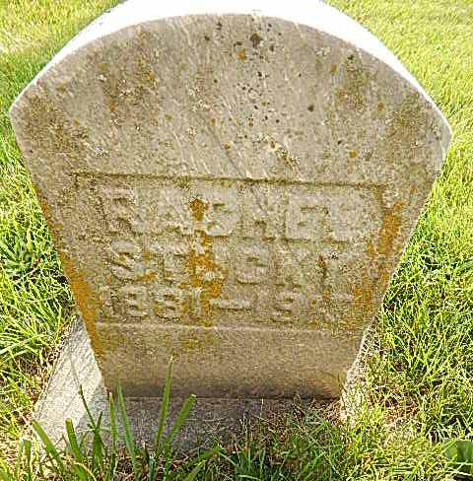
Photo by Alicia Kneuss

Indiana, Marriages, 1810-2001

Name: Rachael Snyder
Gender: Female
Race: White
Event Type: Marriage Registration (Marriage)
Birth Place: Adams
Marriage Date: 2 Apr 1904
Marriage Place: Indiana, United States
Residence Place: Adams, Indiana
Father: John Snyder
Mother: Katie Flickinger
Spouse: Samuel Stuckey
Page: 155
FHL Film Number: 002321357

