Barbara (Rich) Stucky
October 26, 1861 – November 21, 1926
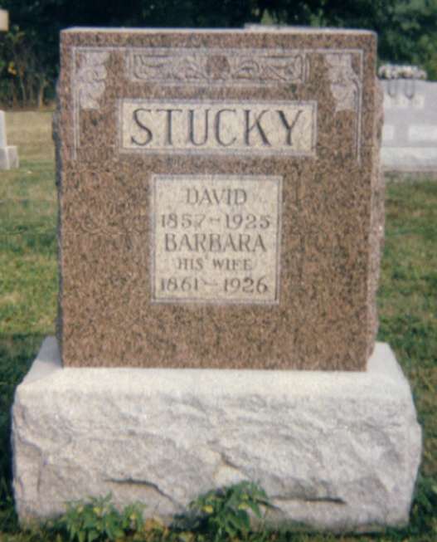
Photo by Carolyn

Indiana, Death Certificates, 1899-2011

Name: Barbara Stucky [Barbara Rich]
Gender: Female
Race: White
Age: 65y, 25d
Marital status: Widow
Birth Date: 26 Oct 1860
Birth Place: Indiana
Death Date: 21 Nov 1926
Death Place: Berne, Adams, Indiana, USA
Father: Joseph Rich
Mother: Anna Moser
Spouse: David Stucky
Informant: Elmer Stucky
Burial: 11/24/1926, Defenseless Mennonite Cem.

