Josephine (Moser) Strahm
June 12, 1908 – November 10, 1979
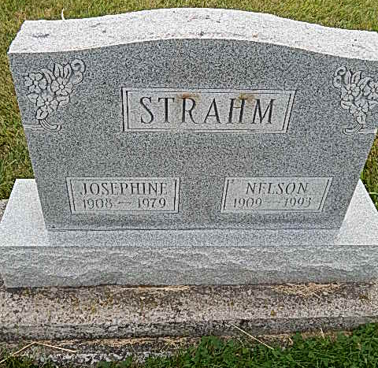
Photo by Alicia Kneuss

Indiana, Death Certificates, 1899-2011

Name: Josephine Strahm [Josephine Moser]
Gender: Female
Race: White
Age: 71
Marital status: Married
Birth Date: 12 Jun 1908
Birth Place: Indiana
Death Date: 10 Nov 1979
Death Place: Ft. Wayne, Allen, Indiana, USA
Father: John J J Moser
Mother: Josephine Kocher
Spouse: Nelson Strahm, informant
Burial: Nov. 12, 1979; Evangelical Mennonite

