Audrey Mae (Bleeck) Steury
March 29, 1926 – November 7, 2019

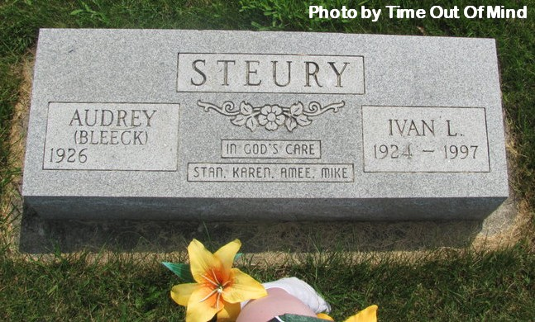

Audrey Mae (Bleeck) Steury passed away on November 7, 2019 at Swiss Village in Berne, Indiana. Audrey was born in Chicago on March 29, 1926, to Ernest and Ida (Davis) Bleeck. With her mother dying from tuberculosis, 18 month old Audrey was admitted to the Salem Children’s Home in Flanagan, Illinois, where she remained for 24 years. Audrey thrived in the nurturing environment created by Director Chester Moser and wife, Helen, who became her “Mom and Dad Moser”. The home’s indelible influence on her life, is evidenced by her strong faith, as well as hundreds of poems, songs, sayings, Psalms and scriptures that she could recite even into her nineties - as can many of her family.
In 1950, Audrey married Ivan Steury who was also employed by the Salem Home. In 1952, they moved to Ivan’s family farm near Monroe, Indiana with a new son. They built a successful dairy farm and added two daughters and another son to the family. The stories of Audrey’s adventures at the Salem Home and the farm were many, and she loved to tell them. She was a warm, kind spirit, who loved to tell jokes and make people laugh and she will be sorely missed by all those who knew her.
Audrey and Ivan were active members of the Evangelical Mennonite Church and later the Mt. Hope Church of the Nazarene. Audrey was active in 4H, the Extension home-makers club and Adams Central School. She was a published poet. Audrey was employed at Swiss Village, Chalet Village, Bank of Geneva, Berne Apparel, and NAAS Foods. Audrey and Ivan moved to Berne in 1990, where she remained after Ivan’s death in 1997. In 2017, Audrey moved to Swiss Village where, for many years, she had been a frequent visitor to dozens of residents. When Audrey was in her 90s, her daughter-in-law and grand-daughter located her brother Ralph (who had passed away in 1992) and a large extended family, whom she had never known. In 2017 Audrey met three of these new family members.
She was preceded in death by her husband, Ivan; her parents; a brother, Ralph, of Longview, WA; son-in-law Donald Crider; granddaughter Emily Steury; and great-granddaughter; Zoey Smith.
She is survived by her children: Stan (Carrie) Steury, Vilas, NC; Karen (Stan) Weaver, Geneva; AmeeCrider, Bluffton; and Mike (Beth) Steury, Berne. Fourteen grandchildren (7 spouses): Drew, Cameron, and Sawyer Steury; Jason Weaver, Laura (Herb) Bergman, Brandi (Jeff) Berkshire, Megan (Tad) Feaster, Katie (Travis) Moore; Abby (Trevor) Yardley, Amber Smith, Jon (Allison) Crider, Chris Crider; Jenna (Adam) Langston and Colton Steury. Twenty great-grandchildren (with 1 spouse): Jordyn, Jarrett, and Ally Weaver; Herb (Andi) Bergman, Madalyn Bergman; Blake and Jayden Berkshire; Aaliyah, Karlie, Cooper, and Miles Feaster; Haleigh Mosser, Emerlynn Moore; Elijah, Raelynn, Noah, and Titus Yardley; Brooklynn Smith; Lewis Crider; and Dylan Langston. Sisters-in-law: Edith Arnold, Berne; Edna Bryant, Pierceton; Martha Steury, Goshen.
Audrey will be remembered with a visitation from 3-8pm on Tuesday, November 12, 2019 at the Zwick & Jahn Funeral Home – Yager-Kirchhofer Chapel in Berne. Funeral Service 11:00 am Wednesday, November 13, 2019 with a visitation one hour prior to the service at the Mt. Hope Church of the Nazarene. Burial will follow at the Berne Evangelical Church Cemetery. Preferred memorials can be given to the Family- Checks payable to Zwick & Jahn Funeral Home or the Salem Children’s Home ( 15161 N 400 E Rd Flannigan, IL 61740)
Arrangements by Zwick & Jahn Funeral Homes – Yager-Kirchhofer Chapel in Berne, Indiana.

Zwick & Jahn Funeral Home, Adams County, Indiana
November 10, 2019

