Noah Stauffer
November 22, 1877 – October 8, 1953

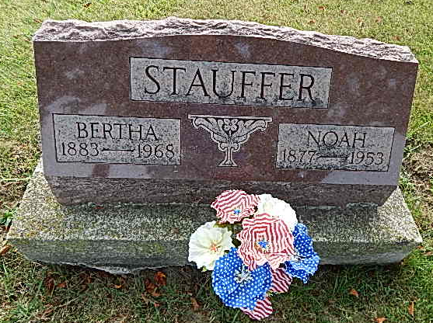
Photo by Alicia Kneuss
WORKER BEHEADED IN PLANT MISHAP
DECATUR, Ind. - A 75-year old handyman was beheaded today when he was trapped in a molasses press at the Liechty Cannery at Berne, 13 miles south of here. The victim, Noah Stauffer, of Rt. 1, Berne, was drawn into the machine when his shirt tail caught in a drive belt as he was lubricating the motor.

Anderson Daily Bulletin, Anderson, Indiana
October 8, 1953
Contributed by Jim Cox
*****
Indiana, Death Certificates, 1899-2011

Name: Noah Stauffer
Gender: Male; Race: White; Age: 76; Marital status: Married
Birth Date: 22 Nov 1877; Birth Place: Adams County Ind
Death Date: 8 Oct 1953; Death Place: Berne, Adams, Indiana, USA
Cause of death: accidental decapitation
Father: Samual W Stauffer ; Mother: Malinda Chrissman
Informant: Meno S. Stauffer
Burial: Oct 10, 1953; Evangelical Mennonite

