Charles Edward Stauffer
April 16, 1950 – February 10, 2009

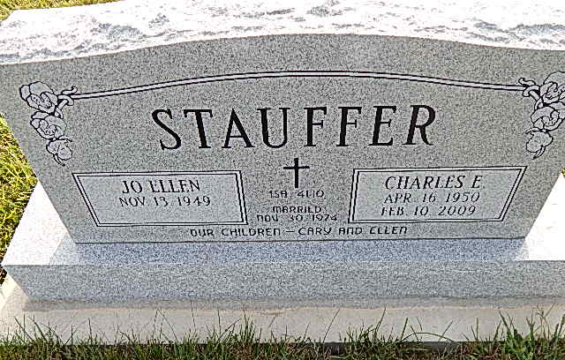
Photo by Alicia Kneuss
Charles "Chuck" Edward Stauffer, 58 of Berne, Indiana passed away at 4:30 a.m. Tuesday, February 10, 2009 in Adams Memorial Hospital in Decatur, Indiana.
Charles was born on April 16, 1950 in Decatur, Indiana the son of Everett and Eileen (Steiner) Stauffer. He married Jo Ellen Williamson on November 30, 1974 in Morton, Illinois.
Charles graduated from South Adams High School in 1968 and from Taylor University in 1972 where he received his bachelor's degree in Sociology. He was employed at Berne Apparel Company for thirty-six years. He was a member of the Evangelical Mennonite Church of Berne, Indiana and served as a Deacon and Sunday school teacher.
Charles is survived by his wife, Joe Ellen of Berne, Indiana; his mother, Eileen Stauffer of Berne, Indiana; a son, Cary (Angie) Stauffer of Berne, Indiana; a daughter, Ellie Stauffer of Berne, Indiana; a granddaughter, Sydney Stauffer; a brother, Loren (Doris) Stauffer of Decatur, Indiana; a brother, Stanley Stauffer of Decatur, Indiana; a sister Karen (Dennis) Rowell of Berne, Indiana. Charles was preceded in death by his father, Everett Stauffer.
Funeral services will be held at 10:30 a.m. Monday, February 16, 2009 at Evangelical Mennonite Church in Berne, Indiana with the Pastor R. Kent Fahl officiating. Interment will be in the church cemetery.
Family and friends will be received from 2:00 - 8:00 p.m. Sunday, February 15, 2009 at the Yager-Kirchoffer Funeral Home in Berne, Indiana and one hour prior to the service at the church on Monday.
Preferred memorials are to the Evangelical Mennonite Church of Berne, Indiana.

Contributed by Alicia Kneuss – no source listed

