Jacob Ernest Sprunger
August 20, 1886 – October 7, 1955

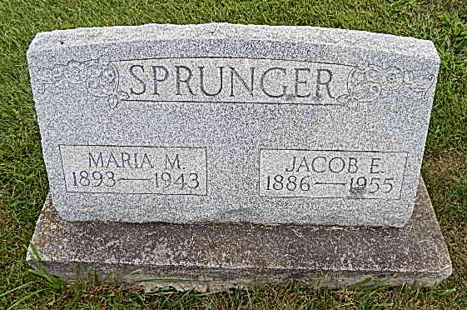
Photo by Alicia Kneuss
Indiana, Death Certificates, 1899-2011

Name: Jacob E Sprunger
Gender: Male
Race: White
Age: 69
Marital status: Married
Birth Date: 20 Aug 1886
Birth Place: Indiana Adams Co Monroe Twp
Death Date: 9 Oct 1955
Death Place: Decatur, Adams, Indiana, USA
Father: Simeon Sprunger
Mother: Emma Huser
Informant: not listed
Burial: October 9, 1955; Evangelical Mennonite Cem.

