Joseph Snyder
1874 – November 17, 1919

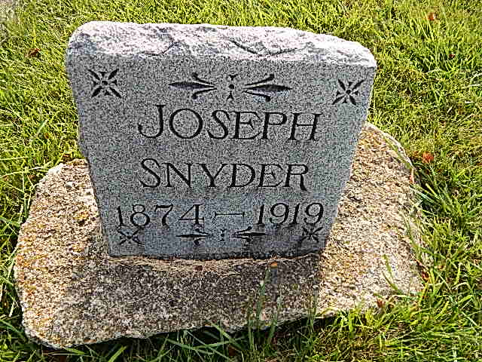
Photo by Alicia Kneuss
Indiana, Death Certificates, 1899-2011

Name: Joseph Snider
Gender: Male
Race: White
Age: 44
Marital status: Single
Birth Date: 1875
Birth Place: Indiana
Death Date: 18 Nov 1919
Death Place: Prairie, Henry, Indiana, USA
Cause of death: crushed by locomotive
Father: John Snider
Mother: Barbara Miller
Informant: can't read
Burial: Nov 19, 1919; Geneva, Ind

