Catherine B. (Flickinger) Snyder
December 28, 1859 – February 17, 1929

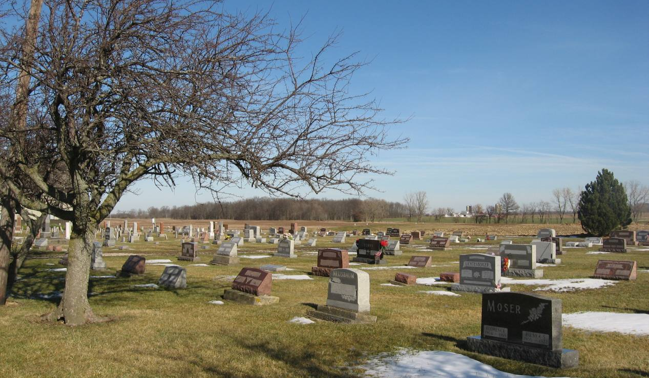
Photo by Tombstoner & Family
Indiana, Death Certificates, 1899-2011

Name: Catherine Snyder [Catherine Flickinger]
Gender: Female
Race: White
Age: 69
Marital status: Widowed
Birth Date: 28 Dec 1859
Birth Place: Russia
Death Date: 17 Feb 1929
Death Place: Berne, Adams, Indiana, USA
Father: Jacob Flickinger
Mother: Barbara Schock
Spouse: John Snyder
Informant: Amos Snyder
Burial: 2/19/1929, Defeseless Menn

