John J. Schwartz
July 6, 1872 – April 6, 1947

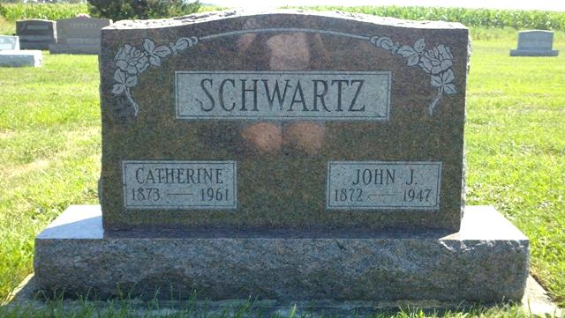
Photo by T & R Melton

Indiana, Death Certificates, 1899-2011

Name: John J Schwartz
Gender: Male
Race: White
Age: 74
Marital status: Married
Birth Date: 6 Jul 1872
Birth Place: Monroe Township Adams Indiana
Death Date: 6 Apr 1947
Death Place: Decatur, Adams, Indiana, USA
Father: Jacob Schwartz
Mother: Maria Liechty
Spouse: Catherine Mazelin
Informant: Simon Schwartz
Burial: 4/8/1947, Defenseless Mennonite

