Elma Evelyn (Steury) Schwartz
June 22, 1904 – December 14, 2012

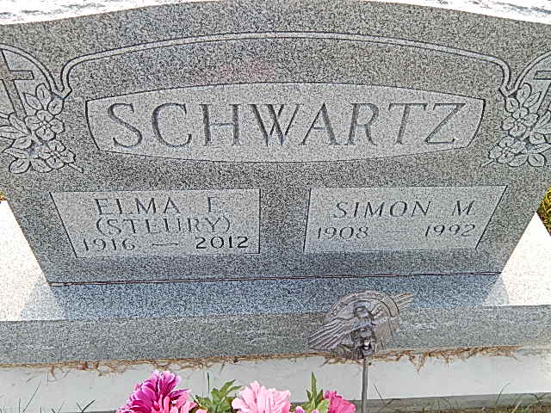
Photo by Alicia Kneuss

Elma E. Schwartz, 96, Berne, passed away Friday, December 14, 2012 at Swiss Village. She was born to Daniel and Catherine (Habegger) Steury on June 22, 1916. She married Simon M. Schwartz on June 22, 1941.
Elma was a member of the Berne Evangelical Church where she sang in the choir and taught Sunday School. She enjoyed gardening, sewing, and sports. She was a seamstress for Stan's Men’s Wear for many years
Survivors include a daughter, Anita (Ronald) Habegger, Fort Wayne, 2 sons, Rodney (Judy) Schwartz, Rotonda West, Fla. and Neil Schwartz, Warsaw; 5 grandchlidren and 11 great-grandchildren. Also 4 sisters, Hulda Kleinknight, Berne, Estella McDaniel, Portland, Verna Tharp, Tucson, Az., Naomi (William) Polstra, Roswell, Ga. Preceding in death are her parents, husband, sisters, Erlina Hawkins, Dora and Flora Steury.
Funeral services are Friday, December 21, at 10:00 am at the Berne Evangelical Church with visitation 1 hour prior to services at the church. Also visitation on Thursday from 5 to 8 pm at the Swiss Village Chapel. Officiating is Pastor Veryl Roth and Kent Fahls.
Burial is in the Evangelical Mennonite Cemetery.
Preferred memorials are to Swiss Village Samaritan Fund &/or Berne Evangelical Church.
Sign guest book at yagerkirchhofer.com

Yager-Kirchhofer Funeral Home, Adams County, IN
September 14, 2015

