Catherine (Mazelin) Schwartz
February 28, 1873 – July 24, 1961

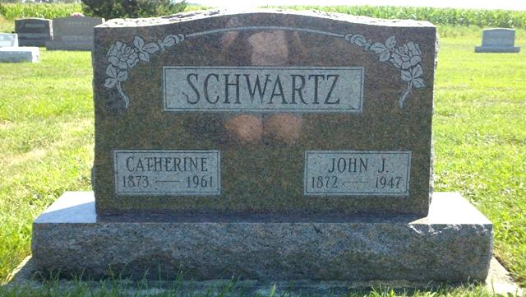
Photo by T & R Melton

Indiana, Death Certificates, 1899-2011

Name: Catherine Schwartz [Catherine Mazelin]
Gender: Female
Race: White
Age: 88
Marital status: Widowed
Birth Date: 28 Feb 1873
Birth Place: Indiana
Death Date: 24 Jul 1961
Death Place: Decatur, Adams, Indiana, USA
Father: Frank Mazelin
Mother: Barbara Schwartz
Informant: Simon Schwart, son
Burial: 7/27/1961, Evangelical Mennonite

