Amos B. Schwartz
January 13, 1932 – February 17, 2013

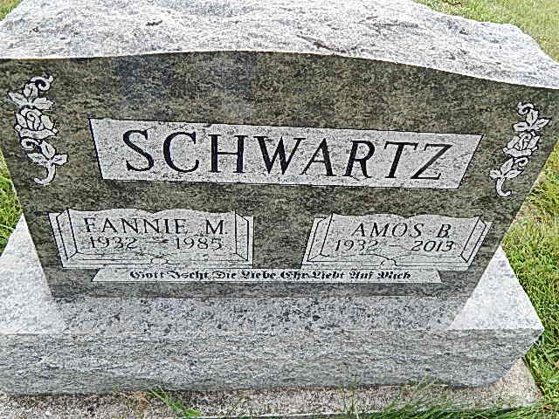
Photo by Alicia Kneuss

Amos B. Schwartz, 81, died Sunday, February 17, 2013, at Bluffton Regional Hospital following a long battle with cancer. He was born on January 13, 1932, to John P. and Barbara (Schwartz) Schwartz in Adams County, Indiana.
He was the 19th of 20 children born into the Old Order Amish home. Early in adulthood Amos and his first wife Fannie (Swartzentruber) established their home in the Geneva, Indiana area where Amos was self-employed as a carpenter. He later founded Rainbow Construction and worked with his sons in Limberlost Construction. During the late 1970's and early 1980's he was the owner of the Little Lamb Play and Learn Center of Alexandra, Indiana. Most recently he has worked as a restorational contractor. He is best known for his work in restoring covered bridges, old barns, and other historic structures. Some of the many organizations with which he was affiliated include Historic Landmark Foundation of Indiana, Indiana State Fair Pioneer Village, Limberlost Land Association, Mennonite Disaster Service, Swiss Heritage Society of Berne, and the Berne Rotary Club.
Amos was an active member of the Berne Evangelical Church having served on various committees and teaching Sunday School classes. His passion for mission work trips led him to South Carolina, Louisiana, and Florida to help rebuild after hurricanes and other natural disasters, and to the Dominican Republic to build a school. Amos was an encourager with a competitive spirit-as many friends on the golf course knew well.
Survivors include his wife of 27 years Neva (Peters) Schwartz, 4 sons, Marvin R. (Linda) Schwartz of Monroe, Kenneth (Lindsey) Schwartz, and Michael L. (Dayon) Schwartz both of Geneva, and Theodore "Toby" Schwartz; 3 daughters, Elizabeth (Gary) Liechty and Cynthia (Steve) Moore both of Berne, and Teresa (Todd) Moser of Fort Wayne; 2 step-sons, Craig Peters of Bellingham, Washington, and Scott (Jennifer) Peters of Geneva, 1 step-daughter, Erin (Chris) Hubbard of Indianapolis and 1 daughter-in-law Lisa Schwartz of Portland. 1 brother, Joseph B. (Rosa) Schwartz of Grabill, and Rachel Hostetler of Sturgis, Michigan; 33 grandchildren and 30 great-grandchildren. Local survivors also include many nieces, nephews, and cousins. Preceding Amos in death were his parents, 10 brothers and 7 sisters.
Visitation for Amos B. Schwartz will be held at the Berne Evangelical Church, 5481 South, 450 West, Berne from 2 to 8 pm on Tuesday, February 19. Funeral services will be held on Wednesday at the church at 10:30 am with visitation 1 hour prior to services. Burial will follow in the Evangelical Mennonite Church cemetery. Officiating is Pastor Kent Fahl.
Suggested memorials are to the Berne Evangelical Church, Swiss Heritage Society of Berne, or the Hope Clinic of Berne/Decatur.
Arrangements by Yager-Kirchhofer Funeral Home. Sign guest book at yagerkirchhofer.com

Yager-Kirchhofer Funeral Home, Adams County, IN
November 19, 2013

