Elizabeth (Augsburger) Schlatter
March 15, 1814 – December 15, 1897

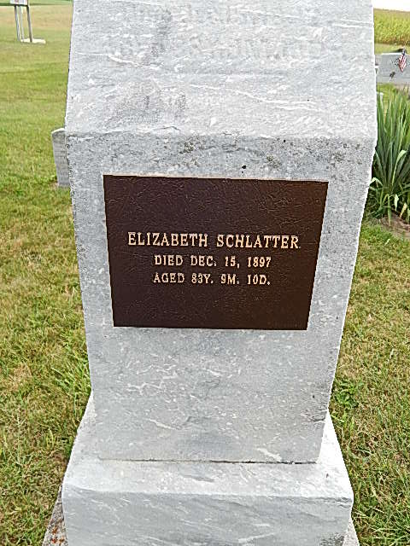
Photo by Alicia Kneuss

Elizabeth Schlatter, maiden name Augsburger, daughter of John and Elizabeth Augsburger, was born on the 15th of March, 1814 in Muenster, Gruenfeld, Switzerland. She was married to Joseph Schlatter in Wayne Co., Ohio on the 29th of March, 1842, to whom she bare five daughters, of whom the two oldest with their father preceded her to the spirit world. She fell asleep in Jesus on the 15th of December, 1897, aged 83 years, 9 months and 10 days. Funeral services by William Egle of Nebraska from 1 Sam. 20:3 in the Mennonite M. H. in Adams Co., Ind.
Herald of Truth, Vol. XXXV, No. 2,
January 15, 1898
Contributed by Jim Cox

