Peter M. Schindler
May 27, 1843 – December 12, 1925

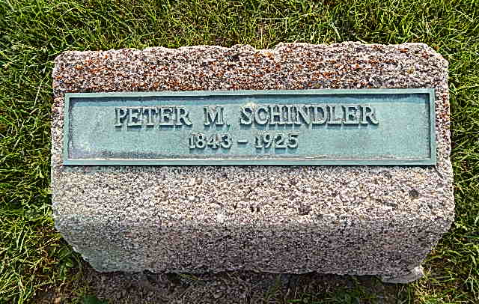
Photo by Alicia Kneuss

Indiana, Death Certificates, 1899-2011

Name: Peter M. Schindler
Gender: Male
Race: White
Age: 82
Marital status: Widower
Birth Date: 27 May 1843
Birth Place: Adams Co Ind.
Death Date: 12 Dec 1925
Death Place: French, Adams, Indiana, USA
Father: John Schindler
Mother: Katie Moser
Spouse: Emma Ashleman
Informant: David Schindler
Burial: Dec 14, 1925; Defenseless Mem Cem

