Christian D. Schindler
May 20, 1833 – December 16, 1901

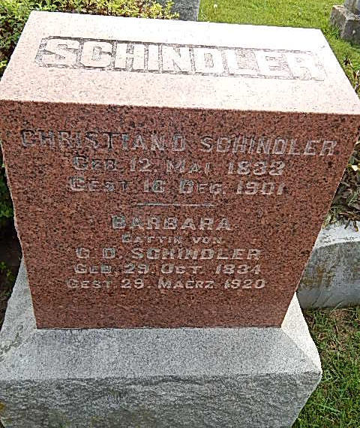
Photo by Alicia Kneuss

Indiana, Death Certificates, 1899-2011

Name: Christian Schindler
Gender: Male
Race: White
Age: 68y, 7m, 3d
Marital status: Married
Birth Date: abt 1833
Birth Place: France
Death Date: 16 Dec 1901
Death Place: Berne, Adams, Indiana, USA
Father: Daniel Schindler
Mother: Mary Liechty
Informant: Jacob Schindler
Burial: Dec 19, 1901; D F Y Cemetery

