Peter Roth
March 17, 1833 – July 15, 1916

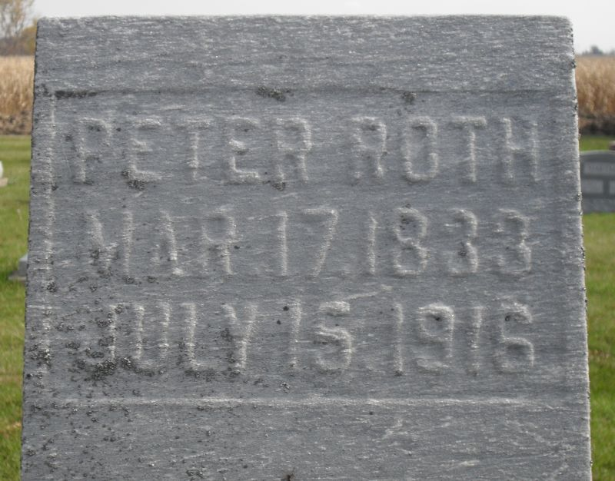
Photo by Stephen & Andrea Brangan

Indiana, Death Certificates, 1899-2011

Name: Peter Roth
Gender: Male; Race: White; Age: 83; Marital status: Widowed
Birth Date: 17 Mar 1833; Birth Place: France
Death Date: 15 Jul 1916; Death Place: Wabash, Adams, Indiana, USA
Father: Jacob Roth; Mother: Madaline Smitley
Informant: Noah Roth
Burial: 7/18/1916, Defenseless Mennonite
*****

PETER ROTH.
Europe has contributed in a large measure the sturdy families who settled and made productive the central western section of this country. The names that are known in the hamlets and villages of many European countries are familiar names in the new world. Strong, vigorous young people severed their home ties and boldly took up the search for a new home and a new beginning in what was to them an alien land. They soon became a fixed and valuable part of their adopted country's social and economic system, and the vast majority of them prospered. A son of such parents is Peter Roth. His father was Jacob P. Roth and his mother was Magdalena (Schmugle) Roth. Both parents were natives of France and crossed the ocean to this country and settled in French township, Adams county, Indiana, in 1849. The elder Roth was a farmer and tilled his farm in French township until his death in 1866. He and his wife were the parents of fourteen children, three of whom are still living.
Peter Roth was born in France and came to America in 1853, four years after his parents. His birth occurred in 1833, and so he was nineteen years of age when he reached this country. In 1860 he married Lydia Horn, a daughter of Christ Horn, who, with his wife, was born in Switzerland. They emigrated to America and settled in Stark county, Ohio, where they followed the calling of farmers. After coming to this country Peter Roth spent one summer in Wayne county, Ohio. He then moved westward to Indiana and bought eighty acres of land in Hartford township. He cleared and improved this land and after his marriage he erected a log cabin and began his earnest life. His life following his settlement on his land was a hard struggle. The days were filled with the hardest kind of manual labor, but he was persistent, and in the end succeeded in getting the better of his antagonistic conditions and found himself in possession of a fine and highly productive farm. Previous to his marriage he worked for other people and cleared something like a hundred acres for them. Today he is in possession of one hundred and twenty acres of fine land. He has replaced the rude log cabin of his earlier days with a fine, modern brick residence and a large and commodious barn. His land is well drained and fenced and his annual crops are ample and are among the best raised in this particular section of the state. His land lies in the Indiana oil belt and six wells have been put down on his property. From these wells he derives the profit from the sale of every sixth barrel of oil pumped, and enjoys a handsome income from this source. He has been a conservative man all his life and has not taken an interest in politics, having never voted.
To him and his wife have been born ten children, seven of whom are still living. His living children are: Christian, Rossanna, Jonathan, David, Mary, Sarah and Noah. Of the family Barbara, Catherine and Levi are dead. He and his wife are highly respected and are counted among the best people of their community. He is a member of the Mission church and takes an interest in all of the things that center about the work and purpose of this church.
Snow's History of Adams County, Indiana, John Fletcher Snow, B. F. Bowen, Indianapolis, IN, 1907, p. 366 (image 751).

