Loren Roth
July 9, 1915 – February 14, 1948

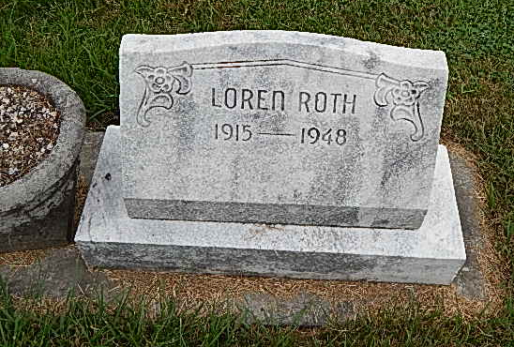
Photo by Alicia Kneuss

Indiana, Death Certificates, 1899-2011

Name: Loren Roth
Gender: Male
Race: White
Age: 32
Marital status: Single
Birth Date: 9 Jun 1915
Birth Place: Indiana Adams County
Death Date: 14 Feb 1948
Death Place: Monroe, Adams, Indiana, USA
Father: Jacob Roth
Mother: Eliza Liechty
Informant: Mrs. Jacob Roth
Burial: 2/16/1948, Evangelical Mennonite Cemetery

