Jonathan Roth
August 12, 1865 – June 27, 1927

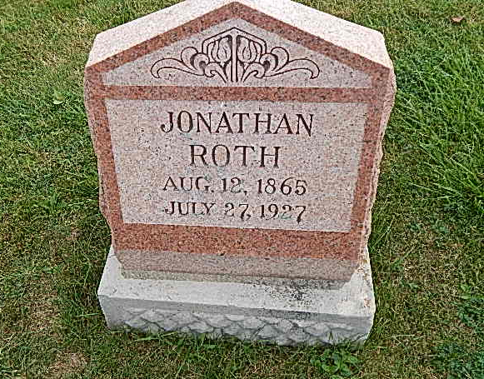
Photo by Alicia Kneuss

Indiana, Death Certificates, 1899-2011

Name: Johnathan Roth
Gender: Male
Race: White
Age: 62
Marital status: Single
Birth Date: 12 Aug 1865
Birth Place: Indiana
Death Date: 27 Jul 1927
Death Place: Hartford, Adams, Indiana, USA
Father: Peter Roth
Mother: Lydia Horn
Informant: Noah Roth
Burial: July 30, 1927; Defenseless Mennonite Cemetery

