Chris H. Roth
December 4, 1874 – May 4, 1939

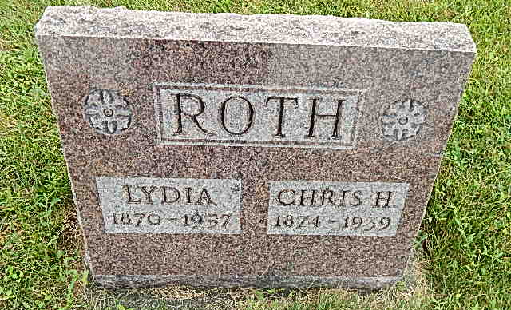
Photo by Alicia Kneuss

Chris Roth Dies Suddenly at Home Today
Heart attack fatal to well-known retired farmer; Rites Sunday

Christian Roth, aged 65, prominent and well-known Linn Grove man, died suddenly at 5:30 o’clock this morning at his home in that village. Death was caused by a heart attack it was said. Mr. Roth was in good health. He arose at the usual time this morning and ate breakfast. Later he was lying on a couch before going to work and suffered the fatal attack.
Mr. Roth was doing odd jobs at the present and was waiting on a neighbor to go to work with him and decided to rest a few minutes. His wife heard him make some unusual sounds and investigated. He died almost immediately. Later Mrs. Roth, prostrated by grief, also suffered a heart attack and was in a serious condition for some time, but is reported improved. William Windmiller suffered a fatal heart attack at the Roth home several months ago while he was visiting there.
Mr. Roth was born in Fulton County, Ohio, 1873, a son of John and Catherine Hostettler Roth. He was married to Miss Lydia Yoder on February 11, 1897. They moved to this county in 1907 and Mr. Roth retired from farming 16 years ago. He was well and widely known.
Surviving are the wife and two sons, Clarence Roth of Fort Wayne and Raymond Roth of Bluffton. One brother survives, Eli Roth of Archbold, Ohio. One brother is deceased.
The funeral will be held Sunday afternoon at 1:30 o’clock at the home in Linn Grove and at 2 o’clock at the Defenseless Mennonite Church, the Rev. N. J. Schmucker officiating. Burial will be in the church cemetery.

Adams County Historical Museum – 1939 Scrapbook
Thursday, May 4, 1939
Transcribed by Jim Co

