Katharina (Yoder) Rich
January 21, 1867 – June 10, 1900

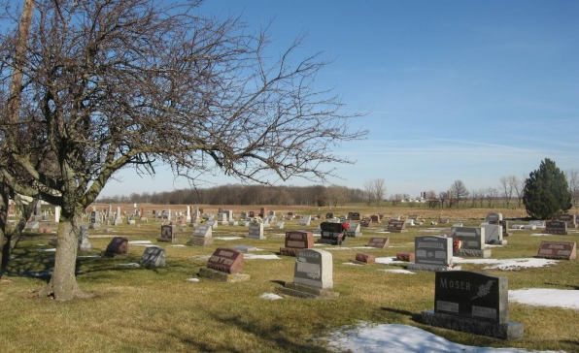
Photo by Tombstoner & Family

Indiana, Marriages, 1810-2001

Name: Katharina Yoder
Gender: Female; Race: White
Event Type: Marriage Registration (Marriage)
Birth Place: Indiana
Marriage Date: 9 Mar 1896; Marriage Place: Berne, Indiana
Residence Place: Berne, Indiana
Father: Jacob Yoder
Mother: Catharina Stukey
Spouse: J J Rich
Page: 30
*****
Indiana, WPA Death Index, 1882-1920

Name: Katie Rich
Date: 10 Jun 1900; Location: Monroe Township
Age: 33 Yr; Gender: Female; Race: White
Source Location: County Health Office, Decatur
Source Notes: The source of this record is the book H-21 on page 13 within the series produced by the Indiana Works Progress Administration.

