Philip D. Nussbaum
September 11, 1901 – August 24, 1965

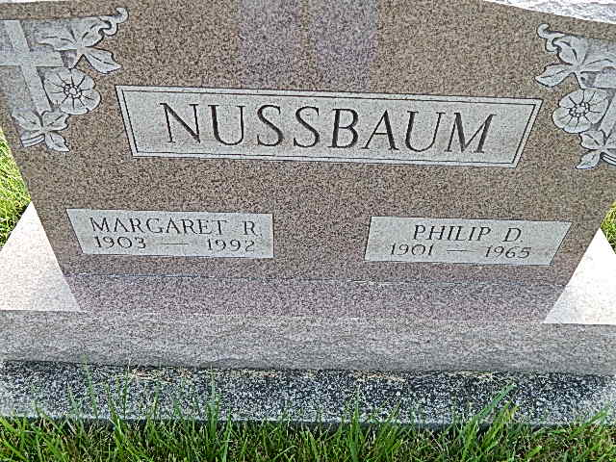
Photo by Alicia Kneuss

Indiana, Death Certificates, 1899-2011

Name: Philip Nussbaum
Gender: Male
Race: White
Age: 63
Marital status: Married
Birth Date: 11 Sep 1901
Birth Place: Adams Co, Ind
Death Date: 24 Aug 1965
Death Place: Rural, Wayne, Indiana, USA
Father: David Nussbaum
Mother: Unknown
Informant: Richmond State Hospital Medical Records
Burial: Aug. 27, 1965; Evan Mennonite

