Peter Neuhauser
December 10, 1859 – November 14, 1943

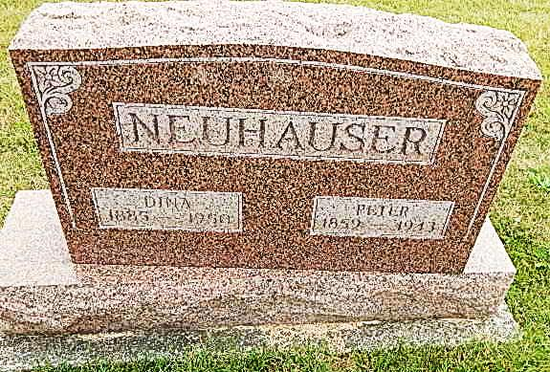
Photo by Alicia Kneuss

PETER NEUHAUSER, 83, RETIRED FARMER DIED EARLY SUN.
Funeral Tuesday Afternoon at Defenseless Mennonite Church

Peter Neuhauser, 82, a retired and well known farmer of French township, died at his home three and one-half miles northwest of town on Sunday morning at 3:30 o'clock, following a four-week serious illness of heart ailment and asthma. Mr. Neuhauser, who was a life-long resident of French township, has been ailing ever since last spring and only recently did his condition become critical.
The deceased was a son of Peter and Barbara Schmucker-Neuhauser, and was born on December 10, 1859. He was married to Miss Dina Neuenschwander on May 27, 1915. There are no children.
Surviving besides the widow is a sister, Mrs. Katie Schindler, who resides at the Noah Rich home north of town. The following half-brothers and half-sisters all preceded him: Mrs. Anna Gerber, Maria, Barbara, Daniel and John Moser, Mrs. Magdalena Moser and Mrs. Barbara Schertz, Joseph and Christian Neuhauser, all of this community.
Funeral services will be conducted at 2:00 o'clock Tuesday afternoon at the Defenseless Mennonite church west of Berne, of which he was a member, with the pastor, Rev. N. J. Schmucker, officiating. officiating. Burial will be in the church cemetery.
The body was returned to the residence this afternoon.

Handwritten date: Monday, November 15, 1943
*****
Among those from out of town who attended the funeral of Peter Neuhauser which was held on Tuesday were Sam Neuenschwander, Rev. Jacob Neuenschwander, Mrs. Amos Steiner, Mrs. Menno Neuenschwander and children, Beulah and John, and John Steiner, all of Dalton, Ohio; Mr. and Mrs. Jonas Schlatter, Mrs. Mary Yoder and Mrs. John Liechty, all of Leo; Mr. and Mrs. Jess Moser of Willshire.

Adams County (IN) Historical Society 1943b Scrapbook, Image 142
Handwritten date: Wednesday, Nov. 17, 1943
Both transcribed by Karin King

