Ruby Alice (Moser) Neuenschwander
May 16, 1934 – January 19, 2020

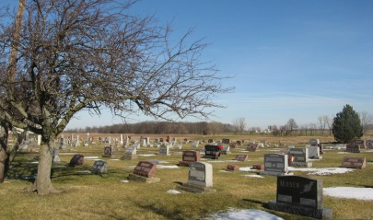
Photo by Tombstoner & Family

Ruby Alice Neuenschwander, 85, of Berne, Indiana passed away on Sunday morning, January 19, 2020, at Swiss Village in Berne.
She was born on May 16, 1934, in Adams County, Indiana to the late Palmer Moser and the late Florence (Sprunger) Moser. Ruby was united in marriage to Wilbert Neuenschwander on July 2, 1960. He preceded her in death on September 24, 2002.
Ruby was a member of Berne Evangelical Church. She taught Children’s church for many years, and served in various capacities at the church. She held a Ladies Bible study group in her home for several years. Ruby and her husband served as Missionaries in the Congo for eight years. She was also a former teacher at Garrett Elementary and Berne Elementary. Ruby along with her husband owned and operated the Maytag Shop in Berne.
She loved her family, and spending time with her grandchildren. She practiced hospitality by opening her home up to friends, missionaries, and extended family. She loved watching birds, reading, and baking.
Ruby is survived by her son, Tim Neuenschwander of Berne, Indiana; son, Ed (Lisa) Neuenschwander of Fort Wayne, Indiana; daughter, Kristi (Tracy) Zurcher of Berne, Indiana; five grandchildren, Reid, Chloe, and Mallory Zurcher, and Natalie, Nathan Neuenschwander.
She was preceded in death by two brothers, Winston and Merle Moser; and sister, Beverly Neuenschwander.
Funeral services will be held at 11:00 a.m. Friday, January 24, 2020, at Berne Evangelical Church located at 5481 S. 450 W. Berne, Indiana , with Pastor John Moser officiating. Private family burial will be prior to the funeral on Friday at Berne Evangelical Cemetery. Family and Friends will be received from 4-8 p.m. Thursday, January 23, 2020, at the Zwick & Jahn Funeral Home, Yager-Kirchhofer Chapel in Berne.
Preferred memorials can be given to Berne Evangelical Church. Arrangements by Zwick & Jahn Funeral Home, Yager-Kirchhofer Chapel in Berne, Indiana.

Zwick & Jahn Funeral Home, Adams County, IN
January 22, 2020

