Peter N. Mosser
December 12, 1873 – January 30, 1941

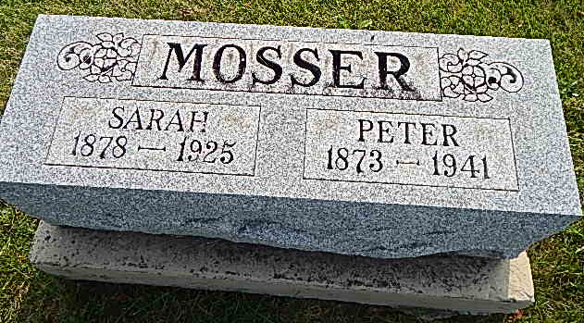
Photo by Alicia Kneuss

Indiana, Death Certificates, 1899-2011

Name: Peter N Mosser
Gender: Male
Race: White
Age: 63
Marital status: Widower
Birth Date: 12 Dec 1873
Birth Place: Adams Co Ind
Death Date: 30 Jan 1941
Death Place: Berne, Adams, Indiana, USA
Father: Peter Mosser
Mother: Barbara Stuckey
Spouse: Sarah Snyder
Informant: Mrs. Jerry Liechty of Berne, IN
Burial: 2/2/1941, Defenseless Menn. Cem.

