Mildred M. (Lantz) Moser
June 23, 1900 – November 30, 1992

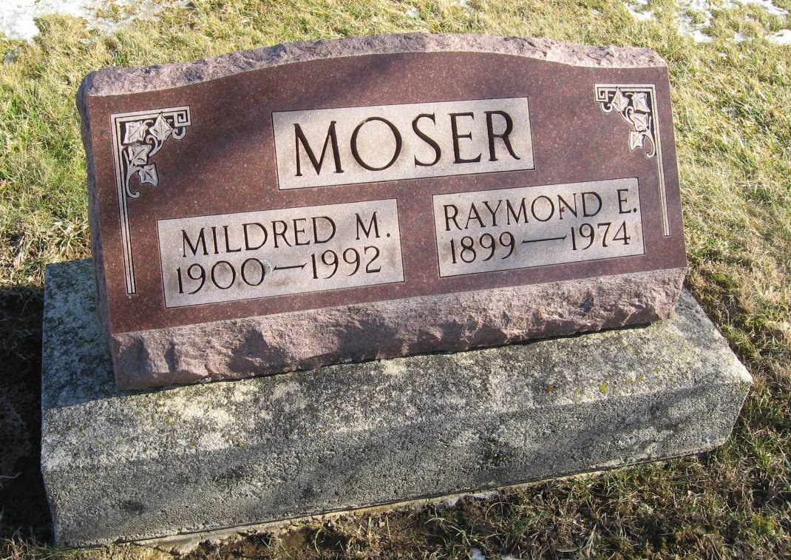
Photo by Tombstoner & Family

MILDRED M. MOSER 92, of Berne died Monday in Swiss Village. The Elkton, Mich., native was the widow of Raymond E., who died in 1974. Surviving are daughters, Doris Steury of Meadows, Ill., Grace Habegger of Sunbury, Ohio, and Betty Habegger of Fort Wayne; eight grandchildren; and 20 great-grandchildren. Services are 10:30 a.m. Friday in Evangelical Mennonite Church, Berne, with burial in the church cemetery. Calling is 2 to 5 and 7 to 9 p.m. tomorrow in Yager-Kirchhofer Funeral Home, Berne, and 9:30 to 10:30 a.m. Friday in the church. Preferred memorials are gifts to Swiss Village or church missions.

News-Sentinel, The (Fort Wayne, Allen County, IN)
Wednesday, December 2, 1992

