Merle Duane Moser Sr.
July 28, 1929 – October 5, 1998

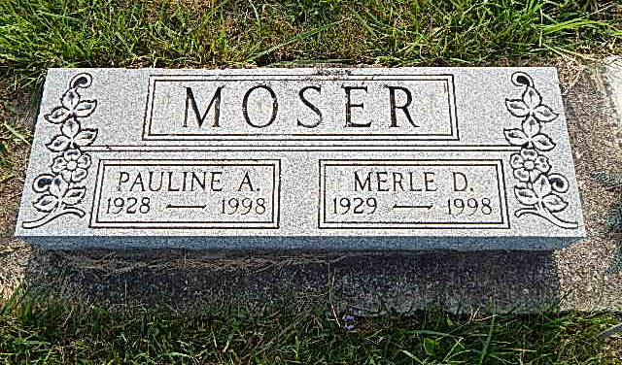
Photo by Alicia Kneuss

MERLE D. MOSER BERNE - 1929-1998
Merle D. Moser, 69, of Berne, a retired truck driver, died Monday, Oct. 5, at Adams County Memorial Hospital. The Adams County native had worked for Sauder Woodworking Co., in Archbold, Ohio, for 19 years, worked for Balsiger Motors for 19 years, was a member of Evangelical Mennonite Church and was a former church trustee, deacon and Sunday school teacher, and an Army veteran. Surviving are his brother, Winston D. of Berne; a sister, Ruby Neuenschwander of Berne; a daughter-in-law, Jill Moser of Berne; and three grandchildren. He was preceded in death by his wife, Pauline, a son, Merle Jr., and one sister. Memorial services are 2 p.m. Sunday at Evangelical Mennonite Church, Berne. There is no calling. Burial will be in Evangelical Mennonite Church Cemetery. Memorials are to Project Share or to the donor's choice. Information provided by Yager-Kirchhofer Funeral Home, Berne, 1-219-589-3101.

News-Sentinel,The (Fort Wayne, Allen County, IN)
Wednesday, October 7, 1998

