Katherine C. “Katie” (Stucky) Moser
August 15, 1866 – March 6, 1946

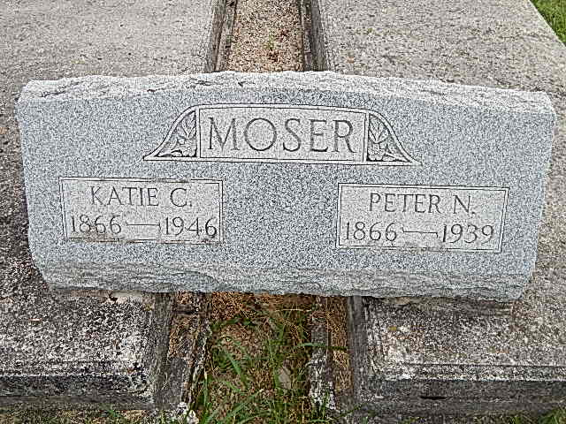
Photo by Alicia Kneuss

Adams Public Library System (Decatur, IN) online obit abstracts

Publication: Decatur Daily Democrat; Date: March 6&8, 1946
Title: Moser, Katie C. Stucky
Subject: Obituaries – M -- 1940-1949
Abstract: Age 79
Born: August 15, 1866 in Adams County, IN
Burial: Defenseless Mennonite Church Cemetery
Married: Peter N. Moser, who died November 19, 1939
Parents: Christian & Fanny Mosser Stucky
Notes: ACHS March 6&8, 1946

