John J. J. Moser
December 30, 1872 – August 9, 1944

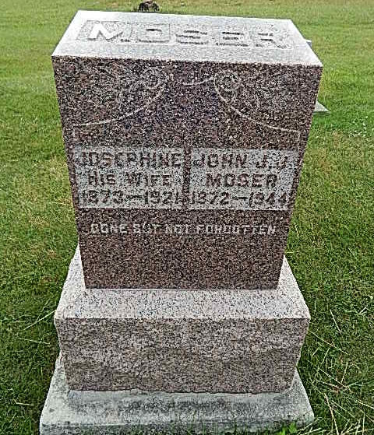
Photo by Alicia Kneuss

Indiana, Death Certificates, 1899-2011

Name: John J. J. Moser
Gender: Male
Race: White
Age: 71
Marital status: Widowed
Birth Date: 30 Dec 1872
Birth Place: Adams Co Indiana
Death Date: 9 Aug 1944
Death Place: Rural, Adams, Indiana, USA
Father: Mike Moser
Mother: Mary Moser
Spouse: Josephine Kocher
Informant: David Moser of Geneva, IN
Burial: 8/12/1944, Defenseless Mennonite

