Delores M. (Litwiller) Moorman
January 11, 1926 – June 20, 2015

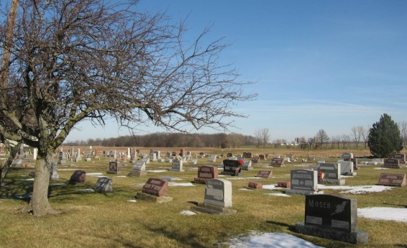
Photo by Tombstoner & Family

Delores M. Moorman, 89, Berne, passed away on June 20, 2015 in Warsaw, Indiana. She was born to Christian and Bessie Yoder Litwiller on January 11, 1926 in Adams county, In. She married Rev. Arvian Habegger who died in 1961 and later married Jesse Moorman who died in 2007.
Delores was a homemaker and a member of the Berne Evangelical Church where she taught Sunday School and was a member of the Ladies Circle. Her interests include; reading, crocheting, sewing, gardening, and traveling. She also enjoyed her Bible studies and loved her family and was a dedicated Christian.
Survivors include 4 sons; Randy (Rosie) Habegger of Marble Falls, TX, John (Sharie) Habegger of Arvada, CO, Neale Habegger of Warsaw, IN, Dean (Elizabeth Morris) Habegger of Libertyville, Ill, daughter, Kathy (Terry) Winteregg of Warsaw, IN, step children; Joan Stephensen of Siloam Springs, AR, Arthur (Judi Crozier) Moorman of Auburn, IN, Marcielle (Don) Barnes of Flagstaff, Az., Molita (Tom) Rittmeyer of Decatur, IN, sister, Juanita (James) Adams of Berne, IN, sister-in-law Marilyn Litwiller, brother-in-laws, Darrell Thiesen, of Nebraska, Robert Meshberger of AR, 13 grandchildren, 26 great-grandchildren, 2 great-great grandchildren, 11 step grandchildren, and 26 step great-grandchildren.
Preceding in death are her parents, husbands, Arvian and Jesse, sisters; Millicent Allison, Marjorie Felger, Verna Thiesen, Romayne Meshberger, brother, Robert Litwiller, and 2 step great-grandchildren.
Funeral services are Friday, June 26, 2015 at 10:30 am at the Berne Evangelical Church with visitation 1 hour prior to services. Visitation also Thursday, June 25, from 4 to 8 pm at the Yager-Kirchhofer Funeral Home, Berne. Officiating is Pastor Kent Fahl. Burial is in the Evangelical Mennonite Church Cemetery rural Berne. Preferred memorials to Ramon & Cindy Garcia @ FEC Ministries. Sign the guest book on-line at yagerkirchhofer.com

Yager-Kirchhofer Funeral Home, Adams County, IN
June 22, 2015

