Christian Mertz

April 18, 1871 – January 9, 1934

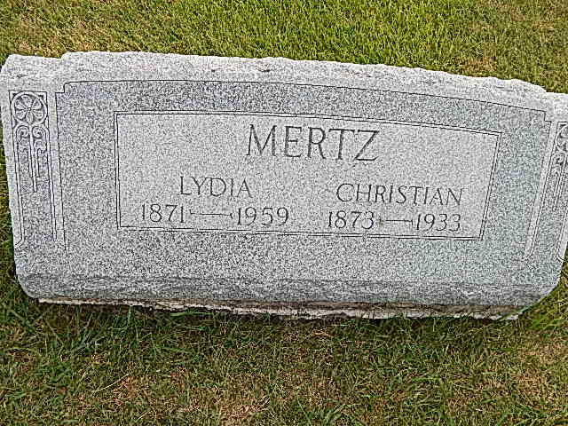
Photo by Alicia Kneuss

Indiana, Death Certificates, 1899-2011

Name: Christopher Mertz
Gender: Male
Race: White
Age: 62
Marital status: Married
Birth Date: 18 Apr 1871
Birth Place: Germany
Death Date: 9 Jan 1934
Death Place: Hartford, Adams, Indiana, USA
Father: John Merts
Mother: Barbara Ann Narr
Spouse: Lydia Mertz
Informant: Liddy Merts
Burial: Jan 12, 1934; Defenseless Mennonite

