Mary Ann (Moser) Liechty
January 10, 1846 – August 5, 1911

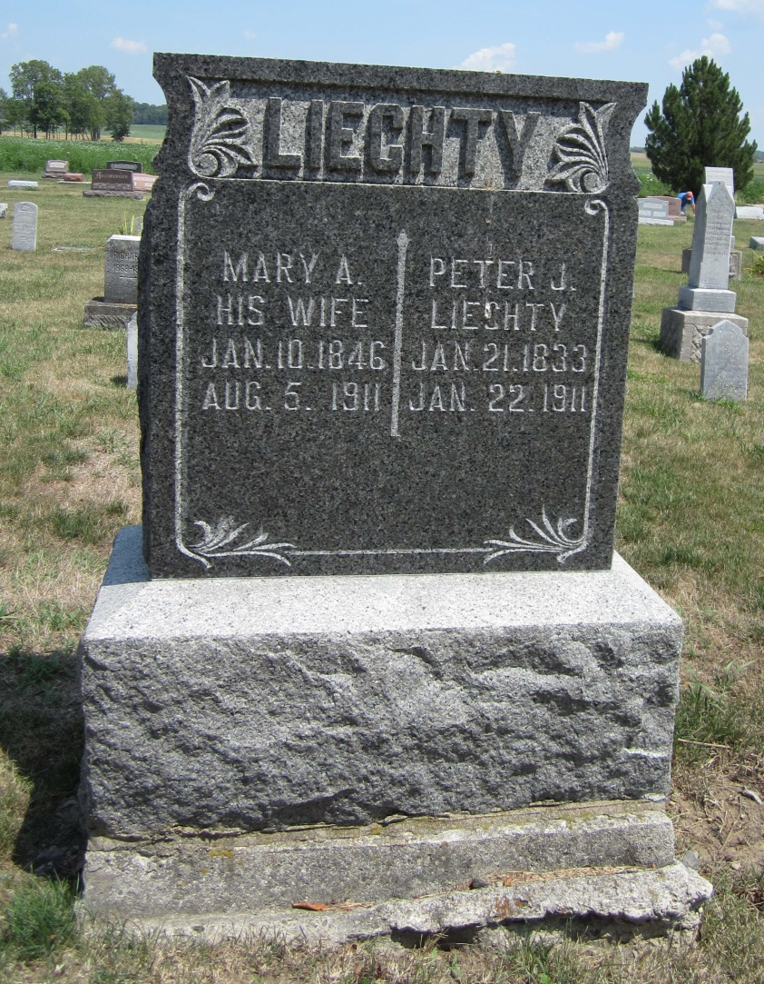
Photo by Carolyn
MRS. MARY LEICHTY DEAD
Geneva, Ind., Aug. 8 - Mrs. Mary A. Leichty (sic), widow of the late Peter J. Leichty, is dead at her home, three miles west of here in Hartford township. She was a pioneer resident of this county. She leaves seven children, three boys and four girls.
Berne Witness, Adams County, Indiana
Friday, August 11, 1911
Contributed by Karin King

