Noah Hirschy
April 1, 1883 – October 12, 1887

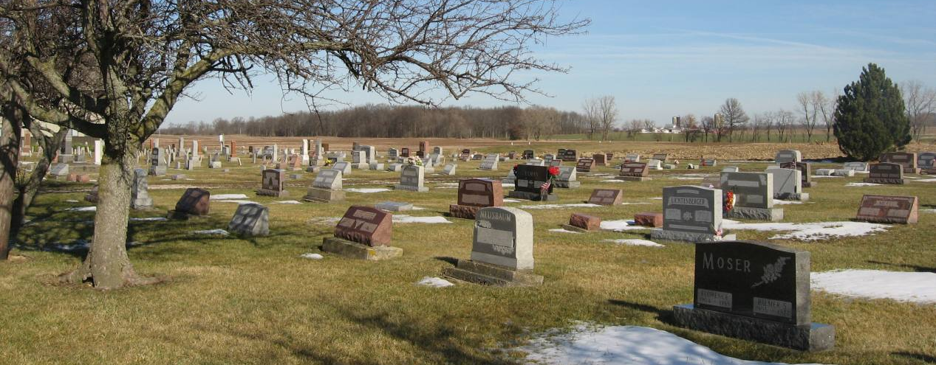
Photo by Tombstoner & Family

Adams Public Library System (Decatur, IN) online obit abstracts

Publication: Decatur Daily Democrat; Date: No date given
Title: Hirschy, Noah
Subject: Obituaries – H -- 1880-1889
Abstract: Age 4
Died: Wednesday, October 12, 1887
Parents: David & Susan Moser Hirschy
Notes: Berne Weekly January 21, 1994

