Anna (Moser) Hirschy
December 13, 1863 – December 9, 1942

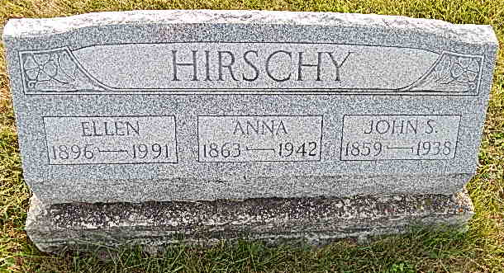
Photo by Alicia Kneuss

Mrs. Anna Hirschy Called by Death Funeral Saturday Afternoon for Aged Lady – Died Wednesday Evening Mrs. Anna Moser Hirschy, who would have reached her 79th birthday anniversary next Sunday, passed away Wednesday evening at 7:45 o’clock at the home of her nephew, Edwin E. Moser, west of Berne. Death was caused by a cerebral hemorrhage which she suffered a few years ago and from which she never recovered. Mrs. Hirschy had been a resident of Linn Grove until October 23, when she was taken to the Moser home for care. The deceased was a native of this community and spent her entire life here. She was a daughter of John and Magdalena Neuhauser Moser. She was married to John S. Hirschy with whom she lived on a farm south of Linn Grove for many years. Mr. Hirschy died four years ago. Surviving are a daughter Ellen, at home, two brothers and two sisters: Mike Moser and Mrs. Katie Fox west of town; Mrs. Salome Zimmerman southwest of Berne and Chris Moser of Battle Creek, Michigan. Preceding her were a brother, Peter N. Moser west of Berne, and a sister, Mrs. Barbara (cut off). Funeral services will be held Saturday afternoon at 1 o’clock from the Edwin E. Moser home and at 1:30 at the Defenseless Mennonite Church with Rev. N. J. Schmucker officiating and Rev. C. J. Gerig assisting. Burial will be in the Defenseless Mennonite Cemetery.
Adams County Historical Museum Feb-Nov 1942 Scrapbook
Friday, December 11, 1942
Transcribed by Jim Cox

