Clara K. (Biberstein) Hartman
March 30, 1910 – January 25, 1989

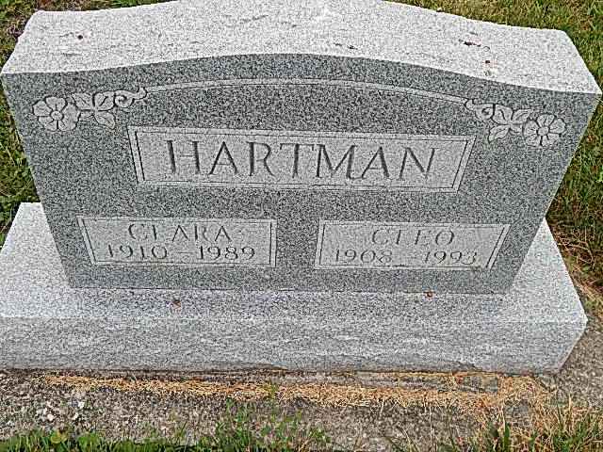
Photo by Alicia Kneuss

Indiana, Death Certificates, 1899-2011

Name: Clara K Hartman [Clara K Biberstine]
Gender: Female
Race: White
Age: 78
Marital status: Married
Birth Date: 30 Mar 1915 (sic)
Birth Place: Monroe Township
Death Date: 25 Jan 1989
Death Place: Berne, Adams, Indiana, USA
Father: David Biberstine
Mother: Mary Moser
Spouse: Cleo Hartman, informant
Burial: January 27, 1989; Evangelical Mennonite

