William Lester Habegger
November 19, 1919 – December 21, 2014

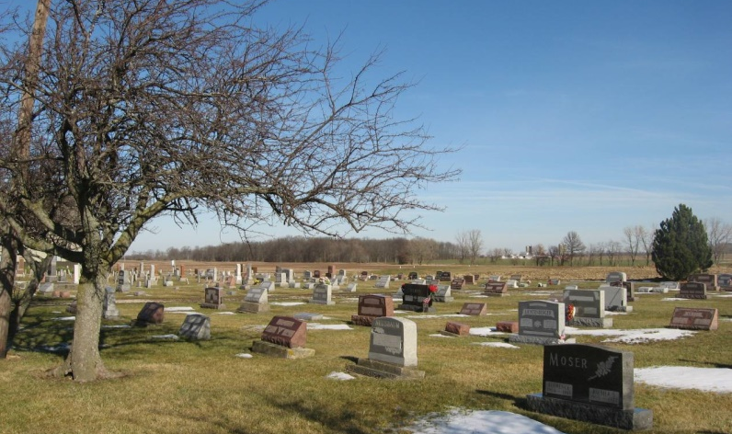
Photo by Tombstoner & Family

SYLVAN D. HABEGGER BERNE - 1910-1998
Sylvan D. Habegger, 87, of Berne, a retired farmer, died Tuesday, Sept. 29, at Adams County Memorial Hospital. Habegger, who was born in Adams County, was a former tester and supervisor of the Diary Herd Improvement Association. He was a member of Evangelical Mennonite Church, Berne. Surviving are his wife, Lucy; sons Roger of Portland, Mich., Loren of Westmont, Ill., and Alan of Athens, Ga.; daughter Nancy Habegger of Fort Wayne; brother Martin of Monroe; sister Viola Dennison of Berne; seven grandchildren; and seven great-grandchildren. Services are 10:30 a.m. Friday at the church, where calling begins at 9:30 a.m. Calling also is 2 to 8 p.m. today at Yager-Kirchhofer Funeral Home, Berne. Burial will be in Evangelical Mennonite Church Cemetery. Memorials are to the church building fund or American Parkinson Disease Association. Information provided by Yager-Kirchhofer Funeral Home, Berne, 1-219-589-3101.
News-Sentinel, The (Fort Wayne, Allen County, IN)
Thursday, October 1, 1998
Contributed by Jane Edson

