Lucy (Graber) Habegger
February 2, 1912 – March 22, 2009

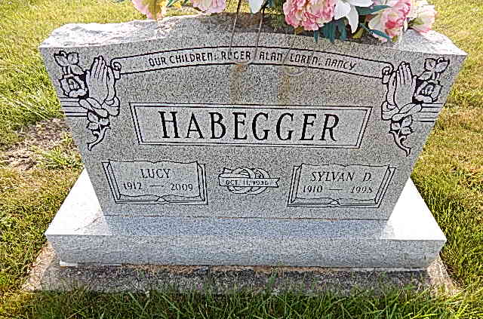
Photo by Alicia Kneuss

LUCY HABEGGER, 97, of Berne, died Sunday, March 22, 2009. Surviving are her children, Nancy Habegger of Fort Wayne, Roger (Shirley) Habegger of Portland, Mich., Loren (Twila) Habegger of Westmont, Ill., Alan (Carole) Habegger of Evans, Calif.; seven grandchildren; 16 great-grand children; one brother; and three sisters. She was preceded in death by her husband, Sylvan D. Funeral service is 10 a.m. Saturday at Swiss Village, Berne, with calling one hour prior. Calling also from 2 to 8 p.m. Friday at Swiss Village. Burial in Evangelical Mennonite Church Cemetery. Memorials to Adams County Community Foundation Arthritis Fund. Arrangements by Yager-Kirchhofer Funeral Home, Berne.
News-Sentinel, The (Fort Wayne, IN)
Tuesday, March 24, 2009
Contributed by Jane Edson
Lucy Habegger, 97, of Berne, Indiana passed away at 9:15 a.m. Sunday, March 22, 2009 in the Adams Memorial Hospital in Decatur, Indiana.
Lucy was born on February 2, 1912 in Adams County, Indiana the daughter of Peter and Catherine (Delegrange) Graber, both deceased. She married Sylvan D. Habegger on October 11, 1936 and he preceded her in death in 1998.
Lucy was a member of the Evangelical Mennonite Church of Berne and was a member of the Womens Society. She was a homemaker and was an equal partner with her husband in managing their dairy and livestock farm. She was a member of the Good Neighbors Home Economics Club and a volunteer in 4-H for many years. She enjoyed quilting, gardening, and baking.
Lucy is survived by a son, Roger (Shirley) Habegger of Portland, Michigan; a son, Loren (Twila) Habegger of Westmont, Illinois: a son, Alan (Carole) Habegger of Evans, Georgia; and a daughter, Nancy Habegger of Fort Wayne, Indiana. Other survivors include seven grandchildren and sixteen great grandchildren.
Lucy was preceded in death by a brother, Henry Graber and sisters, Leah Schwartz, Edna Graber, and Amanda Steury.
Funeral services will be held at 10:00 a.m. Saturday, March 28, 2009 in the Swiss Village Chapel in Berne with the Rev. Todd Moser and the Rev. Anita Rediger officiating. Interment will be in the Evangelical Mennonite Church Cemetery. Family and friends will be received from 2:00 – 8:00 p.m. Friday, March 27, 2009 at Swiss Village and one hour prior to the funeral service on Saturday.
Preferred memorials are to the Adams County Community Foundation, the Arthritis Fund, or the Swiss Village Samaritan Fund.

Yager-Kirchhofer Funeral Home, Adams County, IN
August 1, 2014

