Joseph Peter Habegger
April 9, 1895 – November 20, 1944

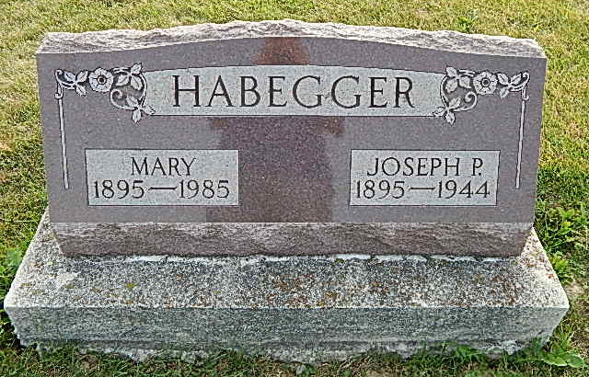
Photo by Alicia Kneuss

Indiana, Death Certificates, 1899-2011

Name: Joseph P Habegger
Gender: Male
Race: White
Age: 49
Marital status: Married
Birth Date: 9 Apr 1895
Birth Place: Adams Co Ind
Death Date: 20 Nov 1944
Death Place: Berne, Adams, Indiana, USA
Father: Peter Habegger
Mother: Rosina Schwartz
Spouse: Mary Nussbaum
Informant: Mrs. Joseph P. Habegger
Burial: 11/22/1944, Defenseless Menn.

