Agnes Emma (Sprunger) Habegger
November 17, 1925 – September 27, 2017

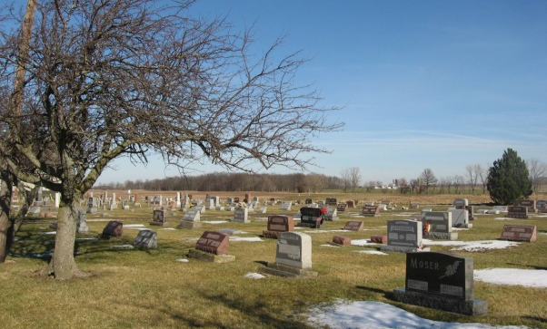
Photo by Tombstoner & family

Agnes Emma (Sprunger) Habegger, 97, Berne, passed away Sunday, October 11, 2015 at Swiss Village. She was born February 26, 1918 to Jacob and Maria (Stucky) Sprunger near Berne and spent her childhood on the family farm west of Berne. She married William (Bill) Habegger April 6, 1941. They deeply loved and cherished each other for more than 73 years of marriage.
Agnes was a member of Berne Evangelical Church, where she was involved in Ladies Aide, taught Sunday School, and served in various other capacities through the years. She and Bill enjoyed traveling and visited all 50 states and many countries around the world. She loved gardening, working on genealogy, hosting family and friends, walking for exercise, interacting with children, and serving in many ways as she and Bill lived in Berne, Fort Wayne, Upland, and in Berne again. Her love for the Lord and her unconditional love for Bill and their family were clearly her primary focus in life and her great legacy.
She is survived by her children, Judy (Milt) Fricke of Kahului, Hawaii; Ro (Jim) Hinzdel of Lake Oswego, Oregon; Cary (Pauline) Habegger of Lebanon, PA.; grandchildren, Matthew (Katharine) Fricke of Harrisburg, Oregon; Scott (Melissa) Fricke of Aliso Viejo, California; Gregory Fricke of Durham, North Caroline; Heidi (Jeremiah) Sensenig of Wyomissing, Pennsylvania; Lisa (Nate) Kelly of North Charleston, South Carolina; Peter (Josina) Habegger of San Francisco, California; Jenny (Wally) Hirsch of Santa Monica, California; Megan Hinzdel of Salem, Oregon; great-grandchildren, Lydia Fricke, Cole Sensenig, Caroline Fricke, Hazel Sensenig, Bella Fricke, Jack Kelly, Jacob Fricke, Owen Kelly, Ruby Habegger.
She was preceded in death by her dear Bill, her parents Jacob and Maria Sprunger, and by siblings Verena (Paul) Rupp, Ivan (Vera) Sprunger, Darlene (Arthur) Neuenschwander, Marieda (Ellis) Neuenschwander.
Funeral services are Saturday October 17, 2015 at 1:30 pm at the Berne Evangelical Church with visitation at 1:00 pm to time of services. Visitation also Saturday, October 17 at Swiss Village Chapel from 9:00 am to 11:00 am. Officiating are Pastors Keith Rupp and Kent Fahl. Burial is in the Evangelical Mennonite Church Cemetery. Preferred memorials are to Berne Evangelical Church &/or Swiss Village Samaritan Fund. Sign guest book at yagerkirchhofer.com. Arrangements by Yager-Kirchhofer Funeral Home.

Yager-Kirchhofer Funeral Home, Adams County, IN
October 30, 2015

