David Fox
October 22, 1858 – March 7, 1926

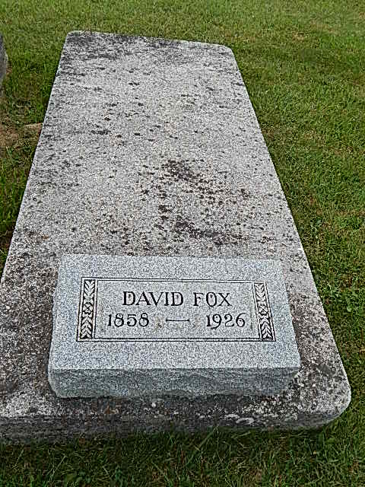
Photo by Alicia Kneuss

Indiana, Marriages, 1810-2001

Name: David Fox
Gender: Male; Race: White
Event Type: Marriage Registration (Marriage)
Birth Place: Indiana
Marriage Date: 25 Jun 1886; Marriage Place: Linn Grove, Indiana
Residence Place: Adams, Indiana
Father: George Fox; Mother: Catharine Steiner; Spouse: Mary Stuckey
Page: 132
*****
Adams Public Library System (Decatur, IN) online obit abstracts

Publication: Decatur Daily Democrat; Date: 08 MAR 1926
Title: Fox, David
Subject: Obituaries -- F -- 1920-1929
Abstract: Age 67
Died: Sunday, March 7, 1926

