John P. Eicher
February 24, 1896 – April 17, 1972

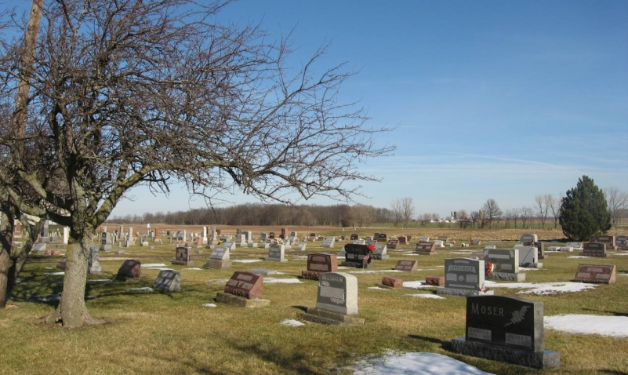
Photo by Tombstoner & Family

Indiana, Death Certificates, 1899-2011

Name: John P Eicher
Gender: Male
Race: White
Age: 76
Marital status: Married
Birth Date: 24 Feb 1896
Birth Place: Indiana
Death Date: 17 Apr 1972
Death Place: Huntertown, Allen, Indiana, USA
Father: Peter Eicher
Mother: Lovina Schwartz
Spouse: Maryann Eicher, informant
Burial: 4/20/1972, Evangelical Cemetery

