Adam Egly
September 1, 1886 – January 7, 1961

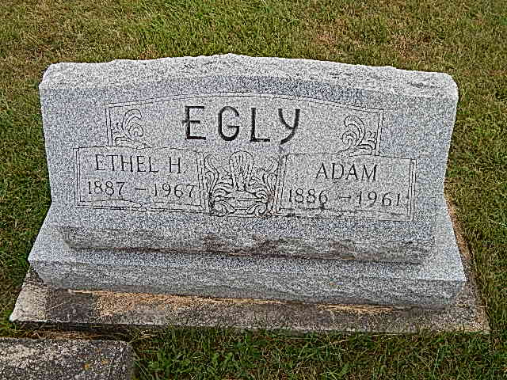
Photos by Alicia Kneuss

Indiana, Death Certificates, 1899-2011

Name: Adam Egly
Gender: Male
Race: White
Age: 74
Marital status: Married
Birth Date: 1 Sep 1886
Birth Place: Indiana
Death Date: 7 Jan 1961
Death Place: Bluffton, Wells, Indiana, USA
Father: Samuel Egly
Mother: Fannie Schindler
Spouse: Ethel Egly, informant
Burial: 1/10/1961, Evangelical Mennonite

