Abraham Egly
February 7, 1862 – November 29, 1938

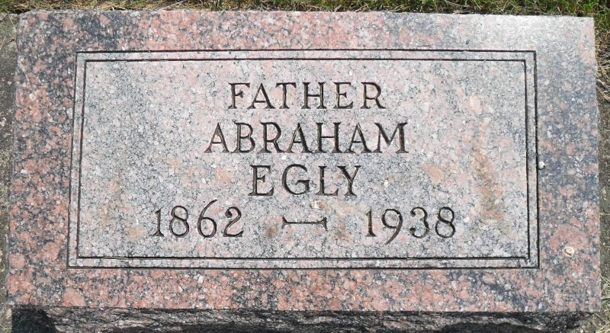
Photos by Stephen & Andrea Brangan

Abraham Egly, 76, Died of Infirmities
Early Tues. A.M. Final Rites for Retired Farmer, Church Worker, Thursday P. M.
Abraham Egly, 76, prominent Hartford township retired farmer and church worker, died Thursday morning at 3:50 o'clock. He had been in failing health for many years and was at the point of death for several days. Cause of his demise which took place on his farm four miles southwest of Berne, was attributed to infirmities. He had suffered a paralytic stroke in 1926 but bore his affliction uncomplainingly.
The deceased was a son of the late Bishop Henry and Catherine Goldsmith Egly and was born on the farm where death occurred, on February 7, 1862. On September 23, 1883 the marriage to Leah Stucky took place. Six children were born to the union.
Surviving with the sorrowing widow are: Simon of Ft. Wayne, Jesse of Forest, Illinois, Mrs. Ben (Amanda) Sprunger, Harve of Berne and Valentine of Monroe. One son, Chris, preceded three years ago. Four brothers, Jacob, Henry, Samuel and Joseph and one sister, Magdalena Schenbeck, preceded.
Mr. Egly was a very active member of the West Missionary church prior to his illness serving the church as deacon, trustee, treasurer and chorister for many years.

Berne Witness, Adams County, IN
Wednesday, November 30, 1938

